
July 2012 Volume VI, No. 3
Among Friends

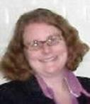 | Best Wishes to an Old Friend  By Holly McCullough, Manager,  Carnegie Library of Pittsburgh – Squirrel Hill  I wanted to share the news that our business and adult services specialist, Dorothy Kabakeris, is taking an early | EDITOR’S CORNER  by Joan Schwartzman  You’ll see my column title has changed from President to Editor of the newsletter. I hope | 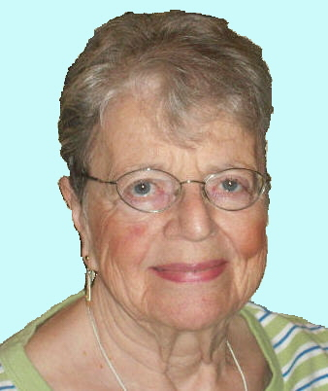
retirement from the Carnegie Library of Pittsburgh as of June 28. Please join us in wishing Dorothy the best and in thanking her for her years of service and dedication to the library and the community. Dorothy has shared that she plans to pursue “fun and fulfillment”. Seems like her next logical step should be Friends membership! |  | you enjoy reading the newsletters and finding all the information therein. Please let me know if you have any ideas or comments. We can’t know how to make our publication better if we don’t hear from you!
A few of us seem to interchange this title, but I assure you all the officers of our best and most-frequently-visited branch library work very hard. I tried to write “exceedingly” but my computer insisted there was no such word. But I digress.  For everyone, member or not, this Newsletter will give you a lot of useful information. It is, of course, better if you are a member; your dues, minor as they are, plus the funds from our book sales (which definitely are not minor) enable the Friends to help not only our own branch but the whole library system. I really feel it’s an honor to be a Friend of the Library; I hope you do too.  Not only is it an honor, but you get to meet some well-read and interesting people. I will now drop a few names, mostly of those who have been with the Friends the longest: Anita Newell, Eleanor Hershberg, Esther Tucker, Joanne Cooper, Joan Schwartzman, Marilyn Honigsberg, Pat Bender, and Margie Spenser. In the next newsletter I’ll mention the more recent, maybe including yours. Have a good summer – and keep reading! |  | WELCOME, NEW MEMBERS  Join us at our regular  Friends Meetings:    Saturday July 7 at 10 AM  Saturday Sept 1 at 10 AM
  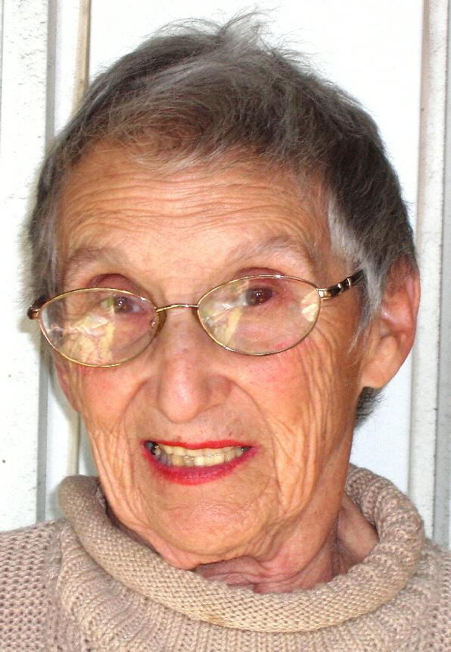 | PRESIDENT’S MESSAGE  by Marion Damick  Well, hello again. Those of you who are long-time members of the Friends of the Squirrel Hill Library may remember that I’ve been President before (several times).
  Joshua Barnes  Michelle Callins Chrissy Carr  Shirley Cohn  Nikki Cunningham  Robert Fierstein  David Goldberg  Kristine Gupta  Jianju Huo  Kim Lincoln | Buzz McWhirter  Brandon Reines  Linda Reingardt  Cathy Rohrer  Shelley Ross  Ryan Reagan  Jennifer  Schnakenberg  James Tew  Jennifer Wright

And the Envelope Please…Congratulations to Holly McCullough and the staff of the Squirrel Hill branch of the Carnegie Library of Pittsburgh. They have been selected as a “Squirrel Hill Treasure” by the Squirrel Hill Urban Coalition. The 2012 Treasure awardees will be honored by the Coalition during their Treasures dinner on October 18th at the Pittsburgh Golf Club. Keep an eye on www.shuc.org for upcoming information on the award and dinner.
..Published by the Friends of the Squirrel Hill Library, 5801 Forbes Avenue, Pittsburgh, PA 15217
editor: Joan Schwartzman mailing list: Allison Marciszyn
production: Dean Damick, Marion Damick, Rita Motor, Margie Spenser, Serena Spenser
websites: www.carnegielibrary.org/locations/squirrelhill & www.pittsburghusedbooks/friends
e-mail: friends@pittsburghusedbooks.com membership email: SqHiFriendsLib@gmail.com
July 2012 | Among Friends | Volume VI, No. 3

Welcome, Miss Rebecca  We are excited to have Rebecca O'Connell joining us as a full time children's librarian. Here are three fun facts she’s told us:  1. I love cats and dogs. I have two cats and a dog, all from  animal shelters (Animal Friends or Animal Rescue League.)  2. I portrayed Dolores Umbridge at the Hogwarts Programs at the Main Library last year (I  still have my pink Dolores Umbridge suit).  3. I write books for babies, children, and teens. Find out more at www.rebeccaoconnell.com. | 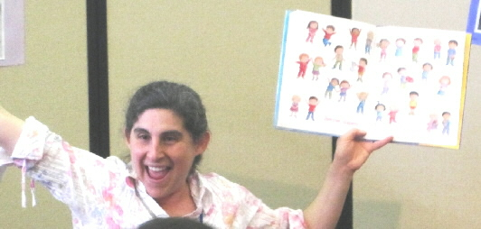

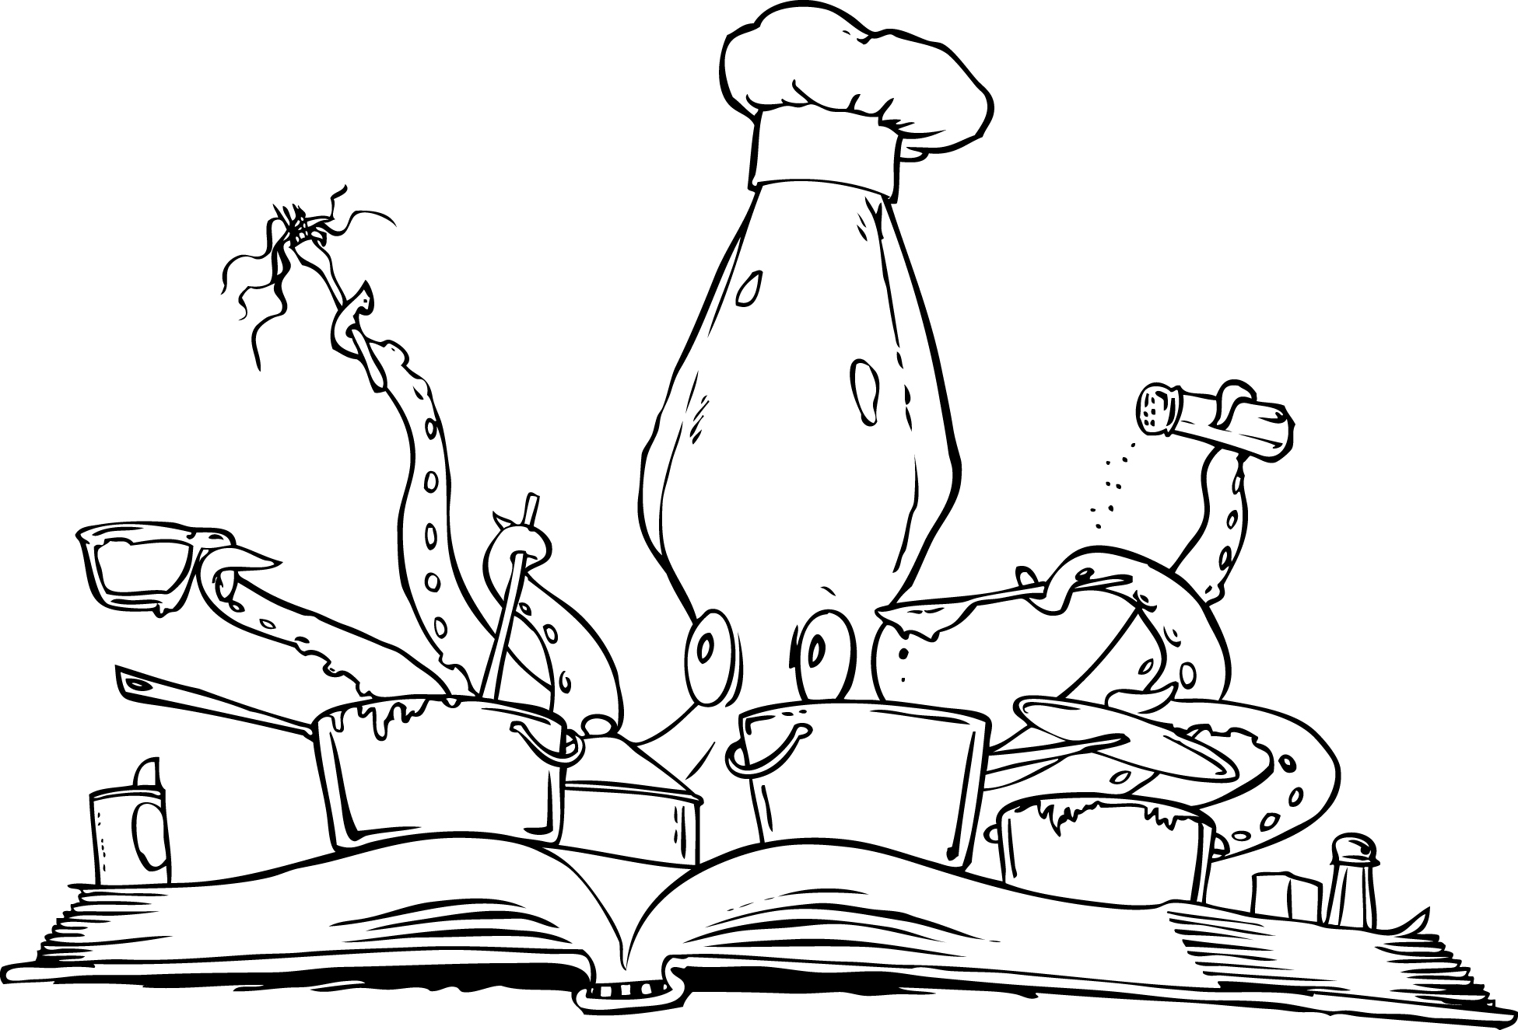 | Children’s Department Summer Happenings  by Rebecca O’Connell, Children’s Librarian  This year’s Summer Reading Club theme is Dream Big—READ! Come into the  library or go to www.carnegielibrary.org/summer and sign up your child for Summer Reading Club! We have two types of programs for children:
- Our Read-to-Me program is for young children who listen to someone read to them. Enjoy the experience of sharing books with your babies or children, while providing them with the six early literacy skills that research suggests all children need to have to become strong readers.

- Our Readers program is for children reading on their own. Research suggests that students who read at least six books over the summer maintain their reading skills, while reading more than six books leads to gains in reading skills.
Both our Read-to-Me and Reader programs encourage children to read or be read to over the summer. Children can earn stickers, prizes, and a chance to win the grand prize in our end-of-summer drawing by reading and keeping track of what they read. | 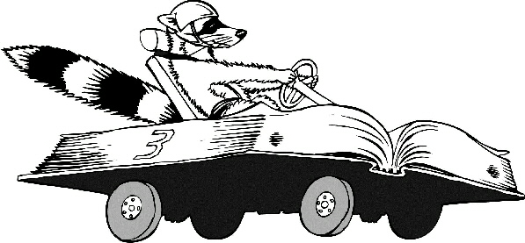 | As an extra reading incentive, The Friends of the Squirrel Hill Library – CLP will donate $.02 to the Squirrel Hill Community Food Pantry  for each book read in the  Summer Reading Club.  (Thank you, Friends!)

In addition to our Summer Reading Club program, we have a variety of fun events for children and their families. These include:

Our Weekly Storytimes:  - Family Storytime (all ages welcome)  Saturdays at 11:00 AM  - Terrific Tales for Toddlers (18 mo. – 3 yrs. old)  Tuesdays at 10:30 AM and 11:30 AM  - Baby & Me (birth – 18 mo.)  Thursdays at 10:30 AM and 11:30 AM  - 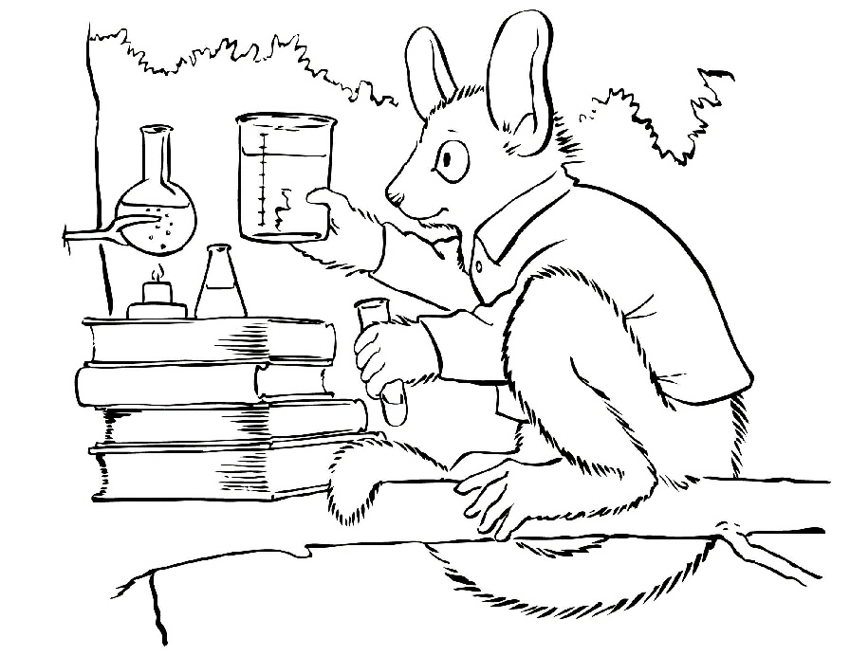  Children today are tyrants. They contradict their parents, gobble their food, and tyrannize their teachers.  Socrates 470-399 BC | School-age Craft Club  (5 – 12 yrs. old), Wednesdays at 4:00 PM  Please register by calling 412-422-9651  or emailing sqhillchildrens@carnegielibrary.org
   |  |  | June | 13 -- | Worry Dolls
   |  |  | June | 20 -- | Dream Catchers
   |  |  | June | 27 -- | Seed Paper
   |  |  | July | 11 -- | Fuse Beads
   |  |  | July | 18 -- | Fairy or Gnome Houses
   |  |  | July | 25 -- | Beaded Keychain
   |  |  | Aug | 1 -- | Sun Catchers
   |  |  | Aug | 8 -- | Nighttime Insect
   |  |  | Aug | 15 -- | Sharpie Tie Dye
   |  |  | Aug | 22 -- | Origami

July 2012 Among Friends Volume VI, No. 3
Thursday Evening Storytimes with Gateway to the Arts

(all ages welcome) 6:00p.m.

Gateway to the Arts partners with professional performing and visual artists to present
programs for children that offer unique experiences with music and art.
.  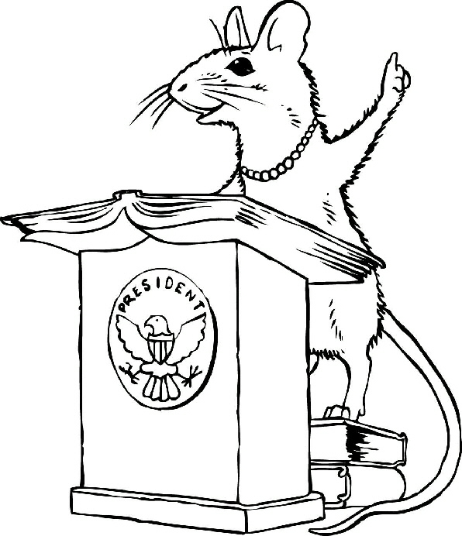 | To register call 412-422-9651 or email  sqhillchildrens@carnegielibrary.org
 | July 5 “El Mar” with Veronica Lopez
 | July 12 “The Great Kapok Tree” with Alison Zapata
 | July 19 “Too Much Talk” with Betty Dell
 | July 26 “Rap-a-Tap-Tap” with Amir Rashidd

 | Local Author  Children's Book Inspired by Painting in Frick  Local children’s author Sydelle Pearl was visiting the Frick Art and Historical Center two years ago when she saw the 1934 painting by Robert Brackman entitled “Somewhere in America”. The little African-American girl sitting on a chair and holding her teddy bear seemed to be looking right at her. Pearl was unable to learn who the little girl was, so she created a story about her called Hope Somewhere in America: the story of a child, a painting, and a president, illustrated by Astrid Sheckels, and published by Twin Lights Publishers in April 2012. |  | 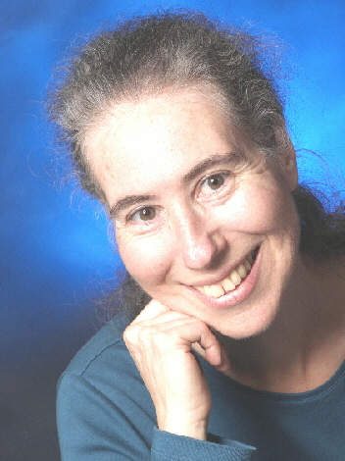
 | 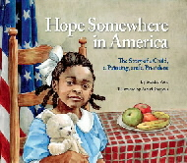 | “Born in Harlem during the Great Depression, a little African-American girl is named Hope Sequoyah for the promise of better times to come and the Cherokee chief who taught his people how to read and write. ‘With a name like yours, you must stand tall,’ her mama always says.  “When Hope is five years old, her mama takes a painting class with Robert Brackman and Hope’s life is forever changed. In her own words, Hope tells of how she gets another name and meets President Franklin D. Roosevelt and First Lady Eleanor – all with her teddy bear by her side.”
Sydelle has been a professional storyteller for twenty years. A native of New Jersey, she has been a Squirrel Hill resident for seven years, and recently planted tomatoes, cilantro, lavender, and chives in the new Squirrel Hill Library community garden.

Sydelle Pearl's website, www.storypearls.com, lists her other books and contains a Teacher's Guide, Intergenerational Guide, Letter to Children, and Book Lists pertaining to Hope Somewhere in America. The book is currently sold at the Carnegie Museum of Art gift shop; downtown at Awesome Books, 929 Liberty Avenue; and at the Penguin Bookshop in Sewickley.
In My Humble Opinion  I’ve been reading a lot lately that was not aimed at my demographic. Today I read Caroline B. Cooney’s book for teens, A Friend at Midnight, and I cried. Nobody died  or went to jail, but a young girl and her family learned more about love, and I got some insights into religious people that had previously eluded me. I also laughed – a lot. The book took less than 3 hours to read but I keep going back, seeing more in her beautiful, economical sentences that describe entire lives and relationships in a few ordinary words. IMHO, if she wrote for adults she’d be a household name.  The Post-Gazette frequently runs reviews of kids’ books in its comic section. Ten new books for babies were listed in May 29’s issue. To find it, go to postgazette.com and search on “10 books”. Check out the other intriguing entries, too. |  |  |  |   Margie Spenser  Newsletter Staff
The Hunger Games books for older teens are a good place to start, but if you google “young adult books” you’ll find vastly more books to enjoy. There is even a national book club at www.foreveryoungadult.com for “YA readers who are a little less Y and a little more A”. The Pittsburgh chapter meets on the South Side; for more information contact Patti at pgreenwood@gmail.com.

I recommend: Louis A. Meyer’s books for teens about Jacky Faber, a female “Oliver” who decides she’ll eat better if she disguises herself as a boy and goes to sea around 1810. Jacky has fabulous adventures as a pirate, a ship’s captain, a British spy, a tavern performer of bawdy songs, a student in a finishing school for proper young ladies … she is captured by (and foils) white slavers, is sent to the criminal colony in Australia on trumped-up charges, and is repeatedly prevented from marrying another “ship’s boy” by (1) his belief that she’s a boy (ick!) (2) his aristocratic family and (3) astounding bad luck and (4) various villains. My mom would have had qualms about some of the story lines, but today’s teens might find them tame. Excuse me; I must go read the 9th book, which I just checked out.

July 2012 Among Friends Volume VI, No. 3
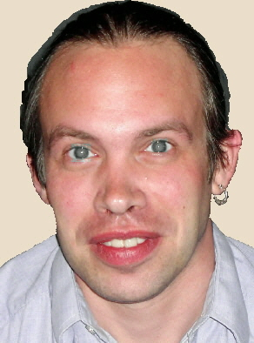  Mark Russell,  Librarian | Fiction,  and Fun | Third Thursday of the month  from 1 to 4 PM  July 19 My Sister’s Keeper by Jodi Picoult  August 16 The Help by Kathryn Stockett  September 20 The Ghost by Robert Harris  Filmed as The Ghost Writer. |   Jeanne Bergad  Moderator
  Film, | 

Film, Fiction, and Fun is a special series presented at the Carnegie Library of Pittsburgh – Squirrel Hill that explores the relationship between films and the novels that inspired them. Attendees are encouraged to read a monthly fiction selection, then join CCAC’s Jeanne Bergad for a screening of the film and discussion to follow.

July 19th’s title is My Sister’s Keeper by Jodi Picoult. Published in 2004, My Sister’s Keeper is the story of 13-year-old Anna, who has been giving blood and tissue all her life to her older sister Kate. Kate suffers from acute promyelocytic leukemia, and when she faces kidney failure and needs a kidney donation from Anna, her young sister decides to sue their parents for medical emancipation. Nick Cassavetes directed the 2009 film version, which starred Abigail Breslin as Anna and featured Cameron Diaz and Alec Baldwin.

August 16th’s book is The Help by Kathryn Stockett. A massive summer hit in 2009, Stockett’s first novel was rejected by 60 literary agents before one was willing to help her bring it to press. The book spent 100 weeks on the New York Times Best Seller list and has sold over 5 million copies to date. Set in Jackson, Mississippi in the 1960’s, The Help chronicles the efforts of Eugenia ‘Skeeter’ Phelan to write a book about the experiences of African-American maids working in white households. The 2011 film version was directed by Tate Taylor and featured a large ensemble cast, including Emma Stone, Octavia Spencer, Viola Davis, Bryce Dallas Howard, and Jessica Chastain. The film received an Oscar nomination for Best Picture, as well as Best Supporting Actress nominations for Jessica Chastain and Octavia Spencer (who went on to win the award) and a Best Actress nomination for Viola Davis.

September 20th’s selection is The Ghost by Robert Harris. Written by Harris in 2007 following the resignation of British Prime Minister Tony Blair, The Ghost is a thriller that begins with the death of a ghost writer. The writer was working on the memoirs of Adam Lang, a recently unseated Prime Minister based heavily on Blair. The narrator of the story is the new ghost writer, who is at first overjoyed at the prospect of such lucrative employment. However, Lang is accused of war crimes, and the ghost writer’s position becomes increasingly tenuous. Harris and director Roman Polanski collaborated on the screenplay for the 2010 film version, The Ghost Writer. The film starred Pierce Brosnan as Lang and Ewan McGregor as The Ghost.

I JUST LIKE MOVIES THAT SOMEHOW EXPOSE THE WORLD IN A WAY THAT’S DIFFERENT THAN YOU IMAGINE IT.
ALEX WINTER 1965-

TYPE THIS PART IN TIMES NEW ROMAN 8 SINCE THE LAST LINE WITH THE NAME AND DATE IS ALWAYS SMALLER

The Squirrel Hill  Adult Book Discussion Group  meets on Thursday  from 1:00 pm to 2:00 pm  All are Welcome.  July 26  Founding Brothers: the revolutionary generation  by Joseph J. Ellis, 2000  August – no meeting  Sept 27  The Happiness Project: or, why  I spent a year trying to sing in the morning, clean my closets, fight right, read Aristotle, and generally have more fun  by Gretchen Rubin, 2009 | BOOK SALE NEWS  by Pat Bender, book sale chairperson  Friends' book sales have been doing very well this year. The April sale earned close to $4000 and Amazon sales for the past three months have totaled $1280. Our gratitude is boundless. It is wonderful for me to have such a positive experience on a personal level and a monetary one. | 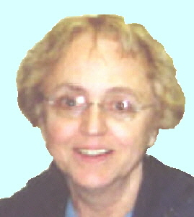
July is on the horizon and we are planning a "Not on the Sidewalk, Sidewalk Sale." Last year's heat was devastating and we had to bring everything indoors. This year, only greeters and signage will be outside, to encourage buyers to enter. Specific plans are not finalized as yet, but our idea is to have some categories of books on the lower level, others on the landing and in the front of the library. The sale will coincide with the Squirrel Hill Happening and the Antique Auto Grand Prix, July 19-22, during regular library hours.
We have relaxed our donation policy so that we now gladly accept books of all kinds and conditions but, as before, no magazines, newspapers, or encyclopedias. Recycle your magazines and newspapers, and if you know what to do with encyclopedias, please let me know.
Also, we will pick up boxes of books at a donor's residence in cases of inability, incompetence, or whatever. Email oursounds@msn.com or call 412-422-3728 and claim whatever.
We are planning a cookbook sale for the month of September.
All of the Friends book room success is possible because of our dedicated volunteers, particularly Drynda Johnson, without whom there would not be a book room, and the many generous members of our community who continue to donate their precious books.
NOTE: the Friends no longer sell books on eBay because Amazon is much more user-friendly.

July 2012 Among Friends Volume VI, No. 3

 | NAMM BUSINESS CENTER PROGRAMS  July – September 2012  by Dorothy Kabakeris, Namm Business Center Librarian  all programs are scheduled for Wednesday at 6:30 PM  unless otherwise noted  July 18 What to Ask Your Financial Advisor
  
to earn more and pay less! Learn how to determine if your advisor is paying attention to your portfolio.
What are the common pitfalls of financial planning? What are the total expenses you are paying?
How do advisors get paid? Why do they change firms?
Presented by Jonathan Heller, JG Heller Private Wealth Advisors, Inc.

July 25 Are You Working on a Big Project Filled With Stress
or are you a graduate student writing a dissertation? Learn how to finish your project or dissertation and thrive, not just survive. Are you overwhelmed, anxious, isolated, self-doubting? These are common problems while working on these major endeavors. In this seminar you will hear about the tools and strategies to help you complete your project or dissertation, minimize the stresses associated with it, and improve your quality of life.
Presented by Betty Fisher, Ph.D., Performance Coach
August 29 at 10:15 AM Laugh and Learn: Laugh Often, Live Well.
Want to relieve stress, power up your immune system and have fun too? Come to this laughter workshop that may transform your workplace and personal space. Learn the ways to carry a joyful life into every day of the week.
Presented by Julie Ann Sullivan, MBA, Certified Laughter Leader

September NO PROGRAMS

SCORE: A counselor is on site to advise small business startups
the first Monday of every month – 10 AM to 1 PM.

FOR JOBSEEKERS: Free resume & cover letter assistance in 45-minute one-on-one sessions with Employment Consultant Shirley Tucker, Ph.D. Fridays 2 to 4 PM in July and August.
For an appointment call 412-422-9650 or speak to a Librarian.

Librarians are nice people. They tell you things, if you ask them.
Jack Reacher in One Shot by Lee Child
Teen Summer Reading 2012  by Maddie Siegel, Teen Librarian  Summer Reading is already in full swing, but it’s not too late to join in on the fun! Teen Summer Reading is a program intended to encourage teens (entering grades 6-12) to read books, magazines, graphic novels and even websites and blogs during their summer vacation. | 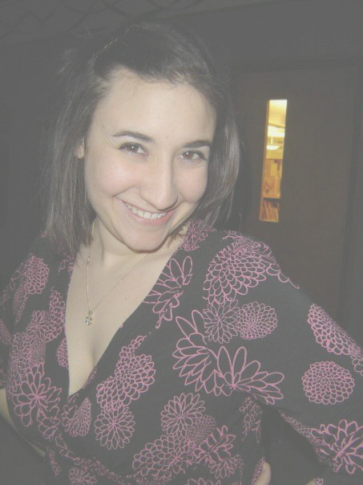
.
How can teens participate?
All aspects of TSR will be online at www.carnegielibrary.org/summer/teens. This includes registration and adding items that you read. Items read may include novels, nonfiction, graphic novels, comic books, magazines and required school reading. Even materials not from the library count!
There are incentives/prizes for participants too!
- Free books & prizes – The Squirrel Hill branch will be giving each teen that signs up a free book and prize.
- Weekly Raffle prizes – Every week from mid-June through mid-August that you enter a book you’ve read into your TSR account, your name will placed in a raffle to win a gift card.. Winners will be contacted by telephone.
- Awesome Grand Prize – One person will be chosen from all CLP teen participants to win a brand new iPad and iTunes gift card! To be eligible to win, simply complete 7 of 13 fun summer activities and hand in your information sheet to the Teen Librarian.
- Teen Fine Forgiveness – We are offering fine forgiveness for teens who register for TSR.
- Weekly Programs – Fridays from June 15 through August 10, from 1:30-2:30 PM in Meeting Room A. Join us for an afternoon of food, crafts, games and more! No registration required.
CARNEGIE LIBRARY OF  PITTSBURGH – SQUIRREL HILL  5801 Forbes Avenue  Pittsburgh, PA 15217  Adult Services: 412-422-9650  Children's Services: 412-422-9841  Fax: 412-422-5811  www.carnegielibrary.org/clp/sq |  | ADDRESS SERVICE REQUESTED  your donation is tax deductible as a charitable contribution | 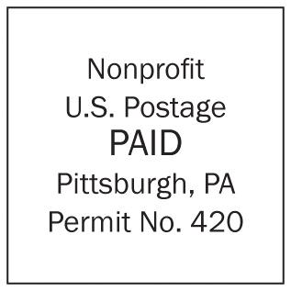
  
  «exptext»  «expdate» | «first» «last»  «addr»  Pittsburgh, PA «zip» «zip2»
Is your Friends Membership up to date? Please check your mailing label. ➔
If the date is before 07/12, you need to renew. Mail us the form below.

This will be the last issue sent to anyone whose membership expired in 2011. Last chance to renew!
The Not on the Sidewalk, Sidewalk Sale (see Pat’s column, p. 4, and the flyer below) is always popular with the many students
who come by looking for foreign language material. Please scour your bookshelves for donations.

July 2012 Among Friends Volume VI, No. 3

make checks payable to:  Friends of the Squirrel Hill Library  and mail to:  Allison Marciszyn  1914 Murray Avenue #24  Pittsburgh, PA 15217  Check one box:  New Member Renewal  Check one OR two boxes:  $5.00 $10.00 $15.00  $25.00 Other___ DONOR (free  for first year)  Name: _____________________________________  ^{(Last)} ^{(First)}  Address: ___________________________________  City/State: ___________________Zip: ___________  Phone(s): ___________________Date: ___________  E-mail address: ______________________________  Please check all activities you can help with:  Periodic Book Sales Sorting Used Books  Adopt-a-Shelf Program Gardening  Library Advocacy Newsletter/Website  (lobbying, writing letters)  COMMENTS_________________________  _____________________________ ___ | 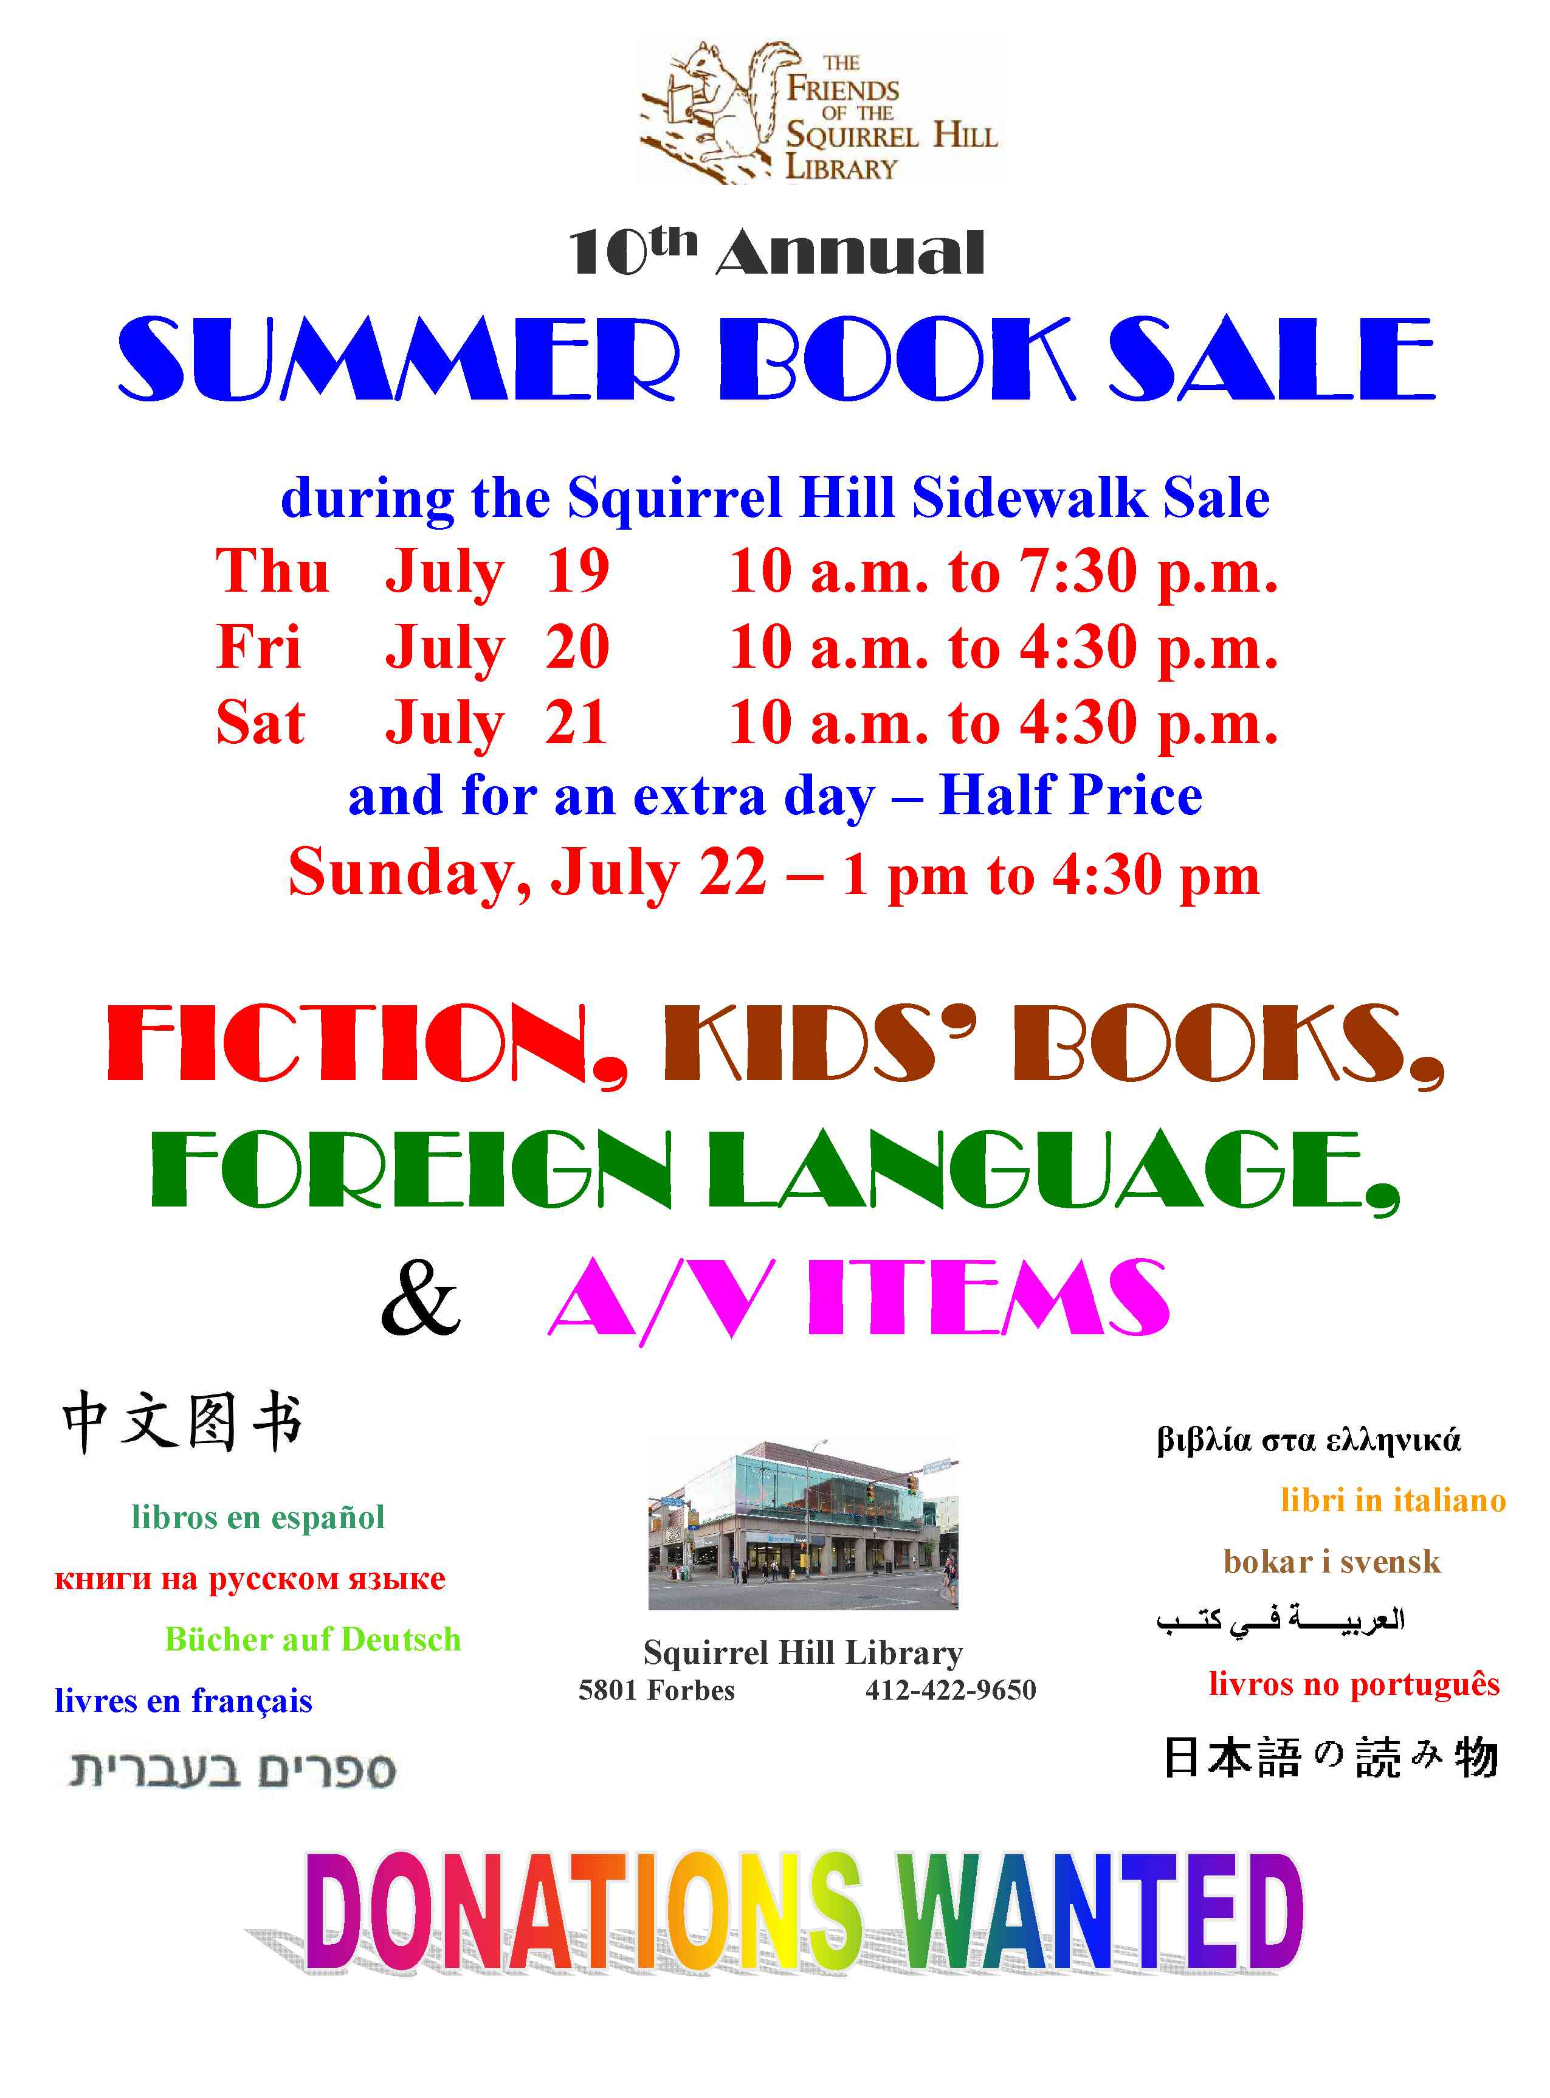  Consider the postage stamp:  its usefulness consists in  the ability to stick to one thing until it gets there.  Josh Billings 1818-1885 | Art at the Squirrel Hill Library    Coming up are:  July: Jack Lees mixed  P. Manny Smollar (age 10) mixed  August: Paul McMillan oils  September: Cele Levine mixed  We are scheduled through May, 2013. To exhibit after that,  call Marion Damick at  412-521-3075.  Friends Officers  Marion Damick President  Marilyn Honigsberg Vice President  Eleanor Hershberg Treasurer  Rita Motor Secretary  email us at friends@pittsburghusedbooks.comm

